Q2)..openvpn configure…

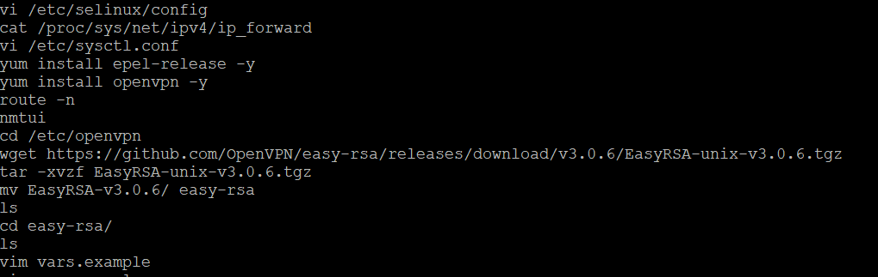

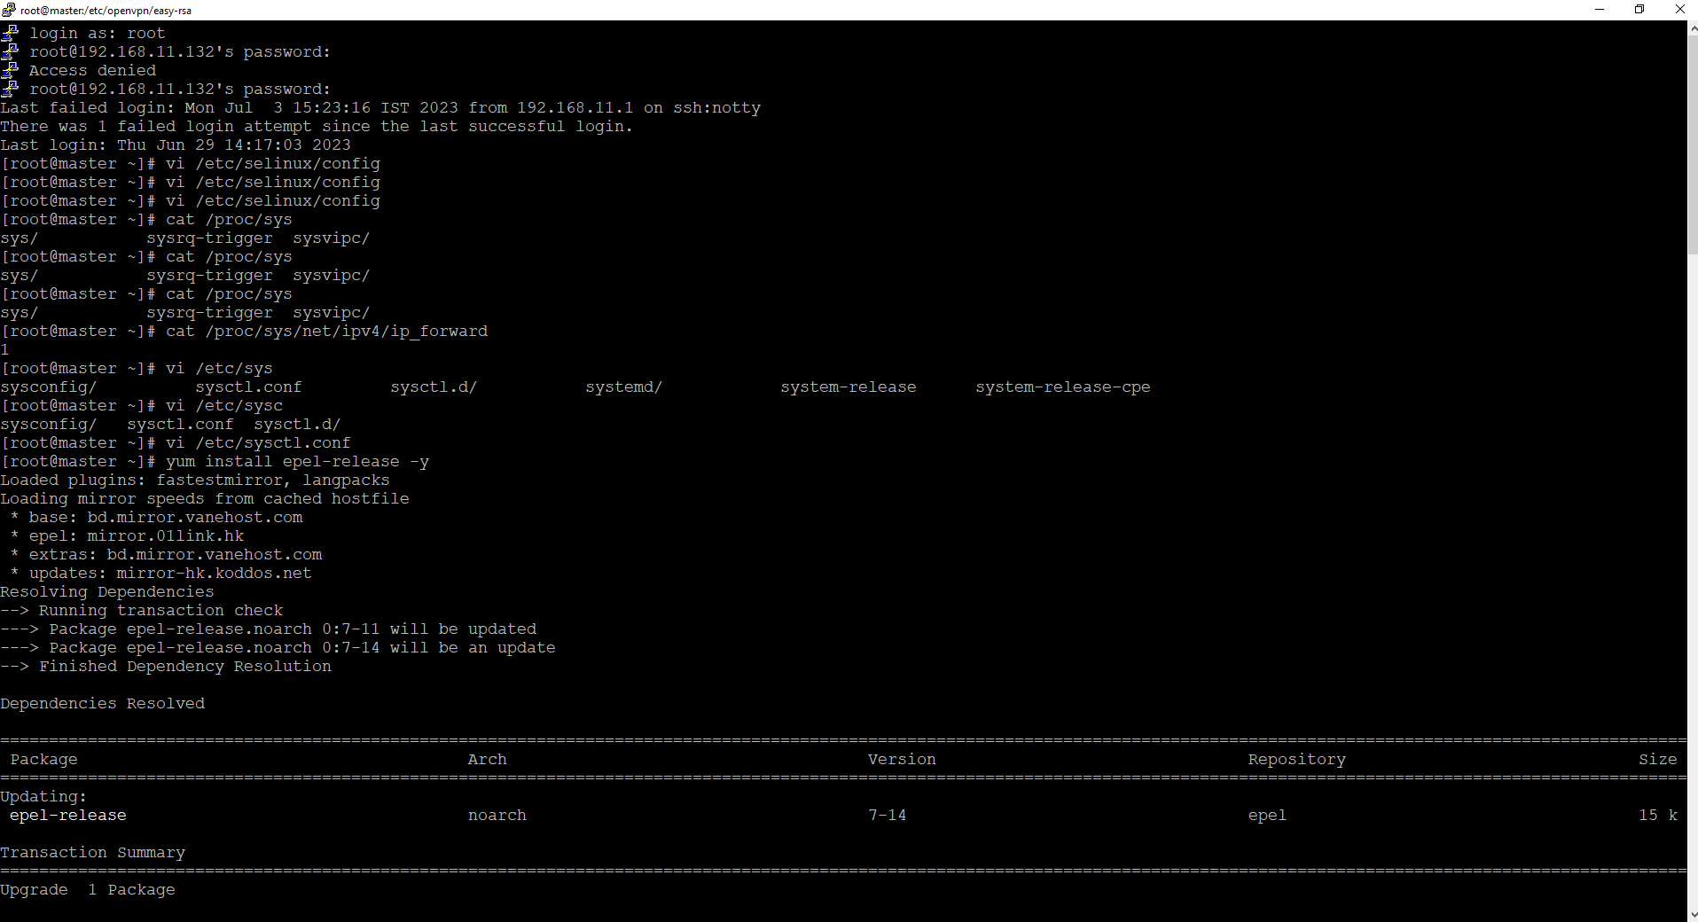

Add cerificate details

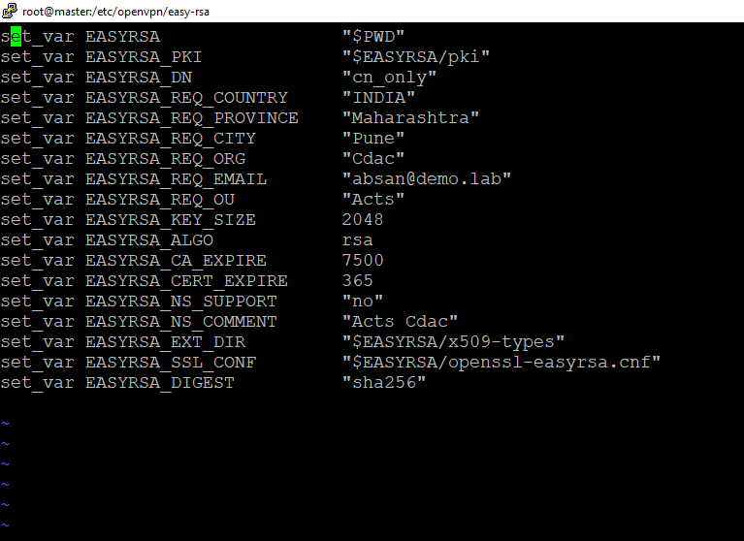



Run Below command and enter the Password and Common Name

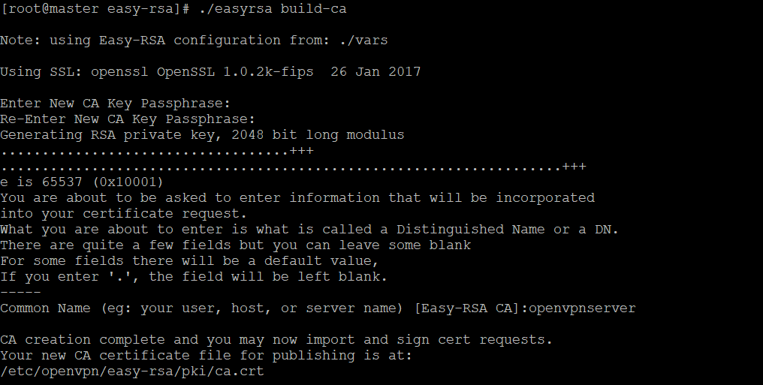

Now Check PVT key and Public key is generate, public key- ca.crt and Pvt key- ca.key



Now generate certificate for server ,give name as demovpn and then Enter while Asking For common Name

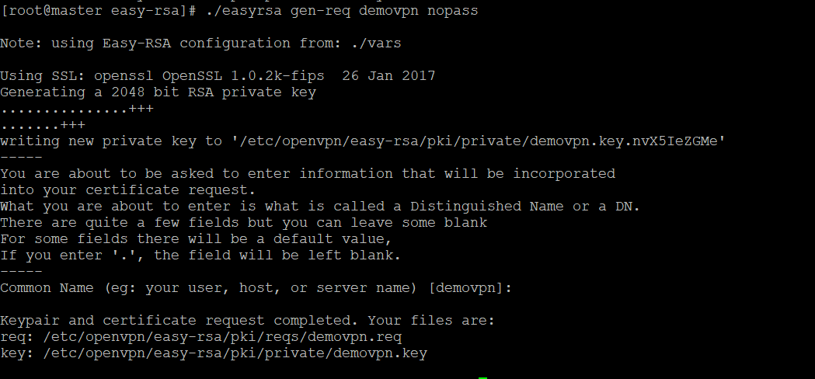

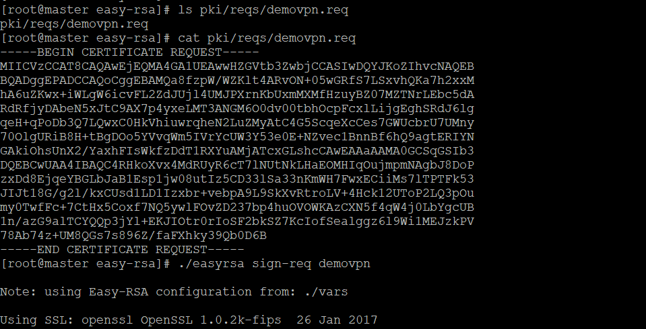

Sign the Server Key Using CA

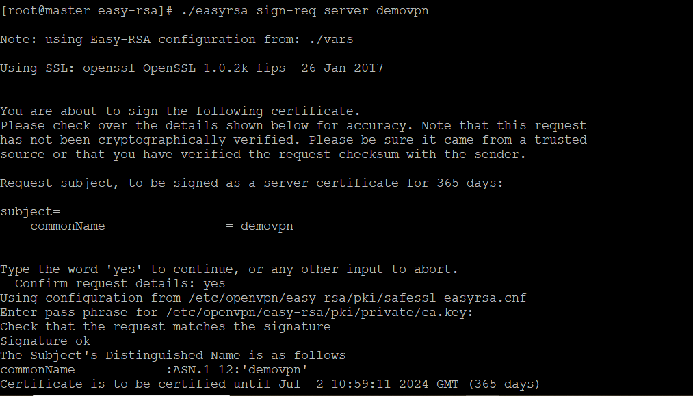

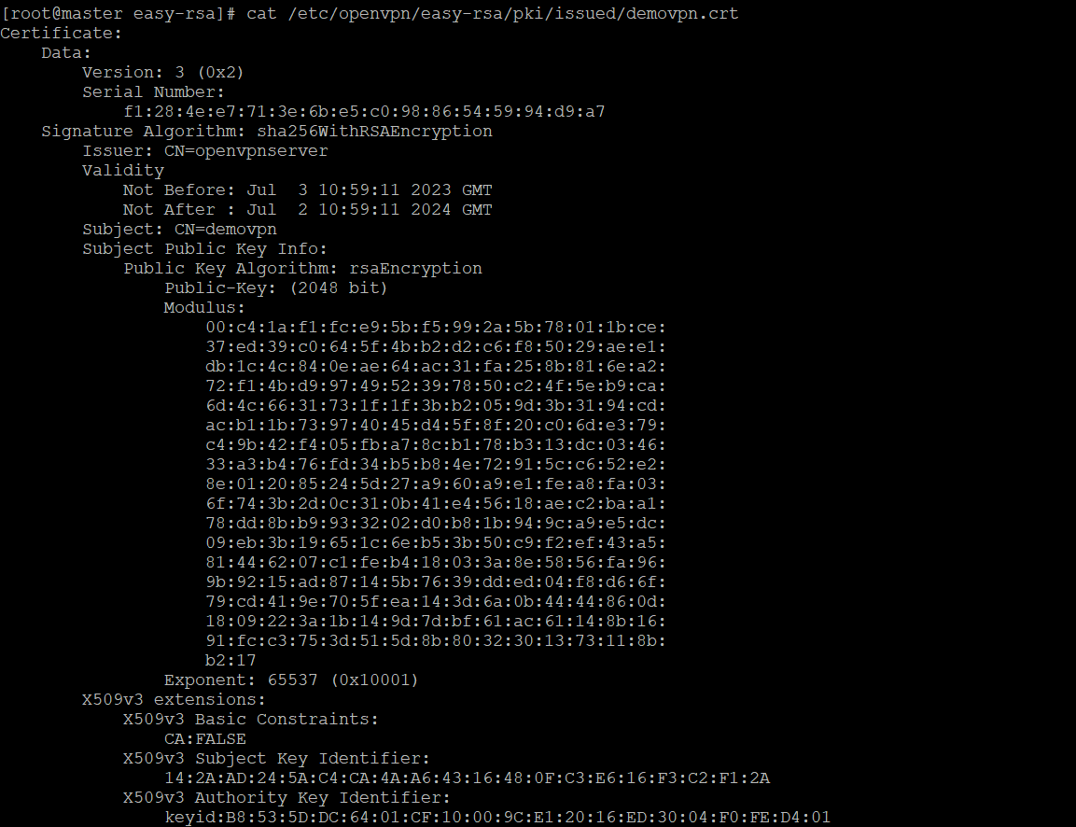

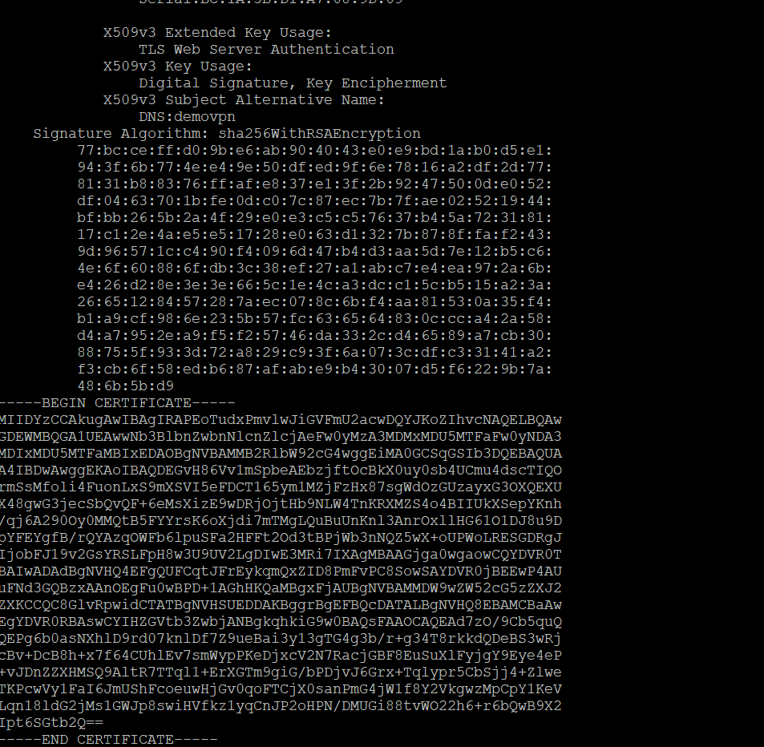

verify the generated certificate file with the following command



Next, run the following command to generate a strong Diffie-Hellman key to use for the key exchange



After creating all certificate files, copy them to the /etc/openvpn/server/ directory



run the following command to build the client key file, Enter the Common name as the clients host name

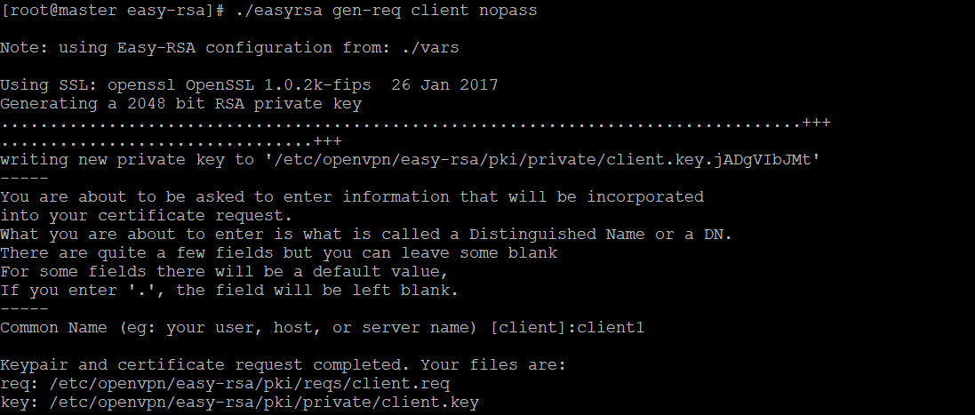

sign the client key using your CA certificate: say yes and enter the password

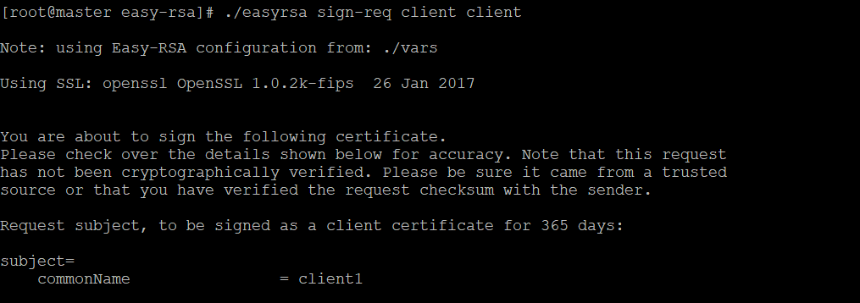

Now Create Certificate For New User Jerry

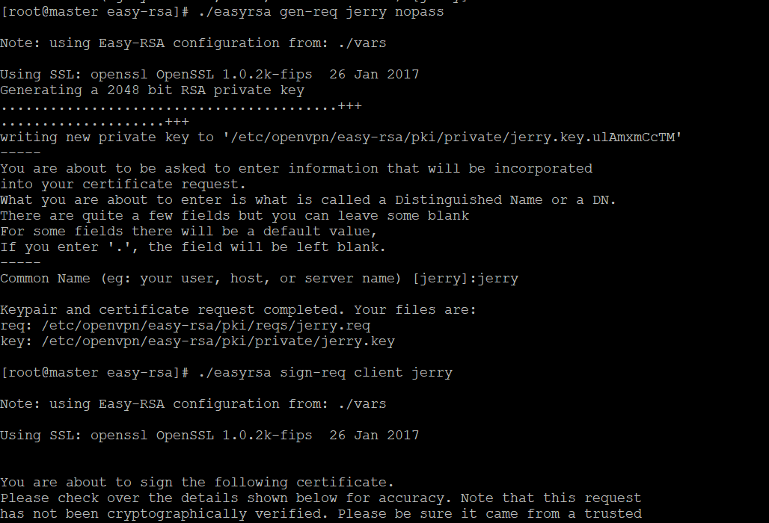

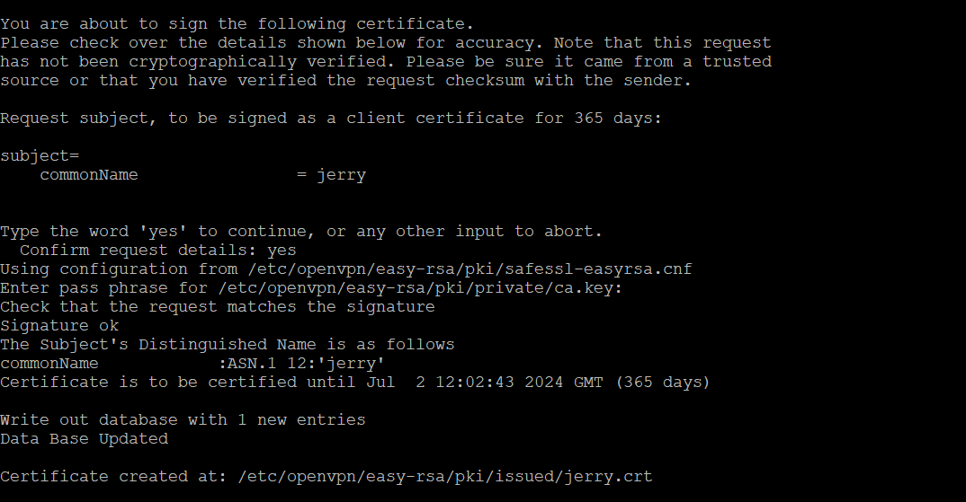

copy all client certificate and key file to the /etc/openvpn/client/ directory:



create a new OpenVPN configuration file inside /etc/openvpn/client/ directory:

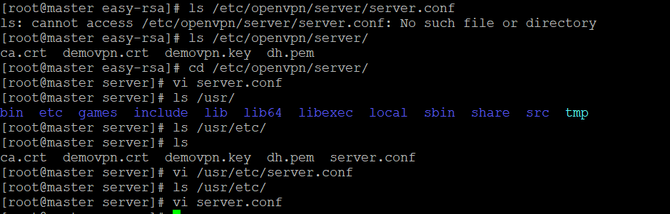

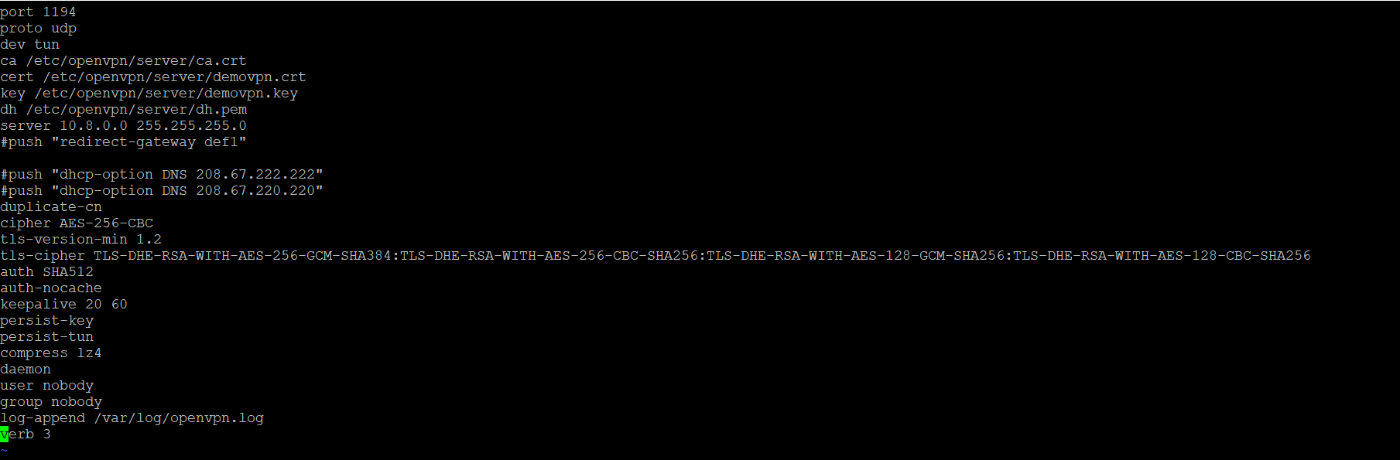

Check the status of openvpn server

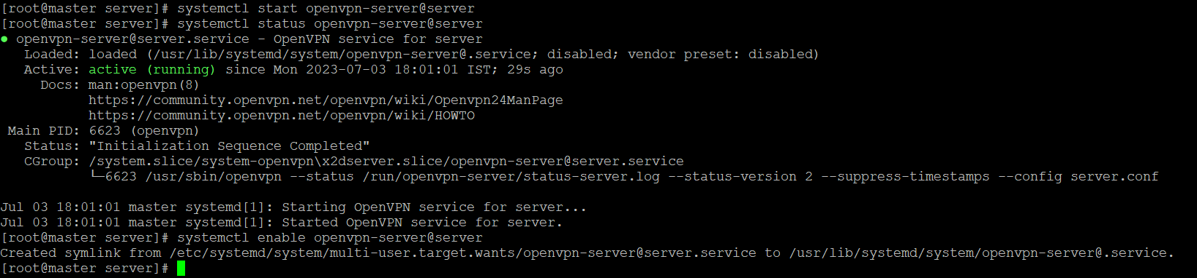

## vi /etc/openvpn/client/client.ovpn

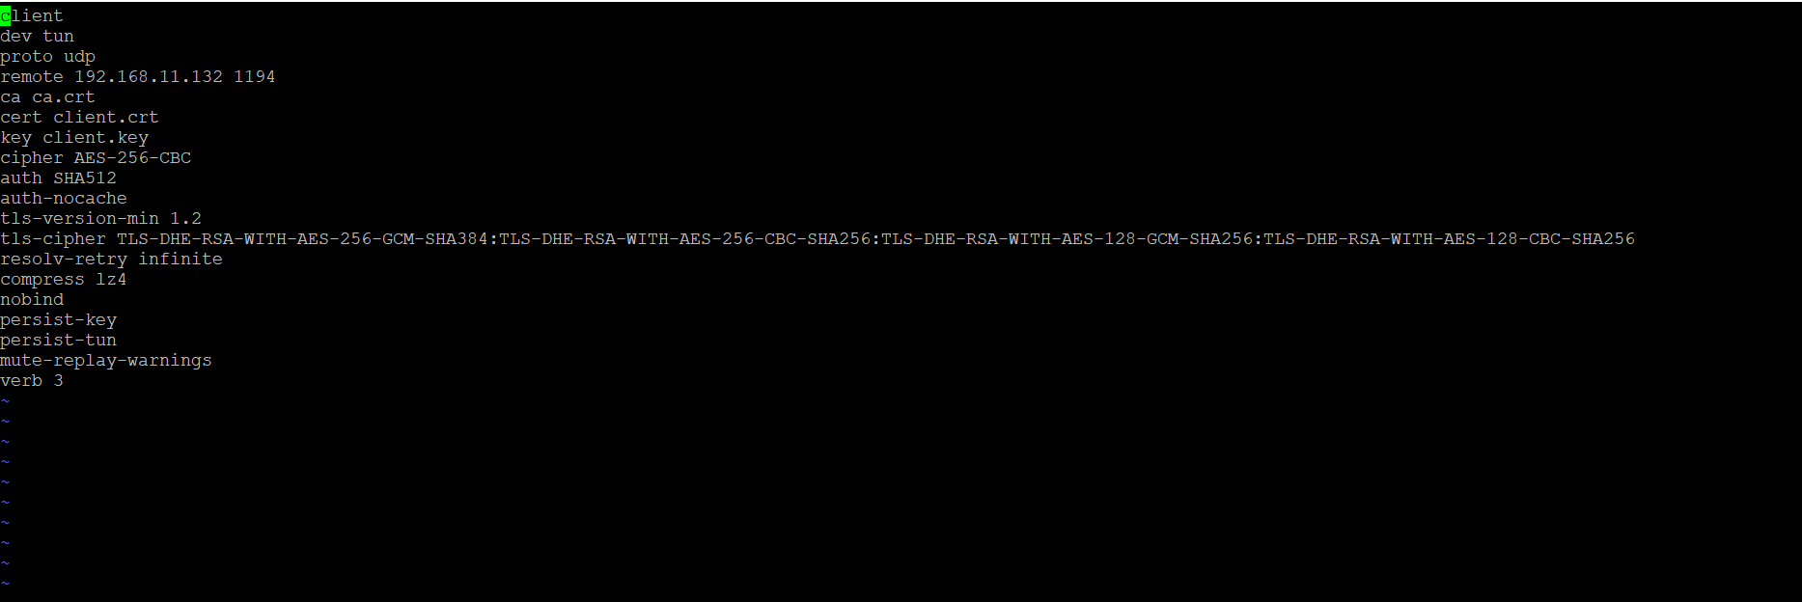

## Install epelrelease and openvpn on linux client

## Yum install epel-release –y

## Yum install openvpn -y

Ifup ens33 ifdown ens33

Systemctl restart NetworkManager

Now try to ping windows ip and access webpage it should be unaccessible.

Give #ip a check for tun0 network adapter then run this command openvpn –config client.ovpn

